|  |  |
| --- | --- |
| Lecturer: | John O’Raw |
| Report Title: | Windows DOS & UNIX exercises |
| File Name: | L00186132.pdf |
| Submit to: | Blackboard in PDF format only |
| Date Submitted: | 22/10/2023 |

|  |  |
| --- | --- |
| Student Name: | PJ McMenamin |
| Student Number: | L00186132 |
| Programme of Study: | PGDip in Cloud Computing (LY_ICTEC_G) |
| Module: | INFS_IT903 |

Table of Contents

Description 3

Aims 3

Methodology 4

Results and Testing 5

Conclusions 6

References 7

Appendices 8

Windows DOS Results: 8

UNIX Shell Results: 10

Software Requirements

Table 1: Software required. 4

Table of Figures

Figure 1: DOS: Create and Delete directories. 8

Figure 2: DOS: Create, Move and Delete files. 8

Figure 3: DOS: Delete and Move files. 9

Figure 4: DOS: Copy command types 9

Figure 5: Create and Delete directories. 10

Figure 6: Create, Move and Delete files. 10

Figure 7: Delete and Move files. 11

Figure 8: Copy files and Remove redundant directories. 11

# Description

This Lab report is a study of Windows & UNIX operating systems commands that are available to users and services to allow interaction with the systems resources via command-line interface (CLI). This report details the basic user commands most frequently used when working with Windows & UNIX systems and how these system commands can be assembled into scripts to automate execution of multiple commands on each system.

# Aims

The primary aims of this report was derived from AUT Letterkenny – PGDip. in Cloud Technologies – Infrastructure as Code (IaC) module, which documented practical Lab exercises during the course and contribute to investigation into benefits/drawbacks when using Windows and UNIX commands. Key aims of the report are:

1. Demonstrate/document Windows DOS CLI commands when working on Windows OS,
2. Demonstrate/document UNIX terminal commands when working in UNIX OS,
3. Capture & summarise both DOS and UNIX commands for easy reference,
4. Summarize advantages/disadvantages of using system commands per OS,

# Methodology

Prior to beginning investigation, the following software version was required to assess Windows and UNIX CLIs. The below software versions were installed on an Azure Virtual Machine (VM) to ensure both CLIs were running on identical configuration.

Table : Software required.

|  |  |  |  |  |  |  |
| --- | --- | --- | --- | --- | --- | --- |
| **Item** | **Description** | **Manufacturer** | **Make** | **Model** | **Serial Number** | **Calibration Date** |
| 1 | Command.com | Microsoft | Windows | 11 | 10.0.22621.2428 | 21Sep23 |
| 2 | Ubuntu CLI | Canonical Group Limited | Ubuntu | 22.04.02 LT | 2204.2.47.0 | 21Sep23 |
| 3 | Workstation, Terminal Server | Azure | Windows | 11 | 0000-0003-3177-8106-6470-6075-37 | 21Sep23 |

This study was conducted to show evidence of completion of lab exercises and document the following goals when observing DOS & UNIX OS commands:

1. Complete all DOS exercises as documented in IaC module lecture notes [1]
2. Complete all UNIX exercises as documented in IaC module lecture notes [1]
3. Referenced DOS best practices/standards available to users [2]
4. Referenced UNIX best practices/standards available to users [3]

# Results and Testing

This section details the testing approach conducted and results that were recorded when reviewing both systems CLIs.

On completion of Windows & UNIX CLI analysis, testing of both CLIs was completed successfully with no issues encountered. Details summary of results recorded are as follows:

***Test 1:*** Create and run DOS commands to manipulate windows operating system as outlined in point 1 in methodologies. Manipulation of the Windows OS included navigating the OS, creation and deletion of directories, creation and deletion of files and reporting OS System information.

***Result 1***: DOS commands were executed successfully with result recorded via output screenshots available in Appendix 1 – Figure 1, 2, 3 & 4.

***Test 2:*** Create and run UNIX commands to manipulate UNIX operating system as outlined in point 2 in methodologies. Manipulation of the UNIX OS included navigating the OS, creation and deletion of directories, creation and deletion of files and reporting OS System information.

***Result 2***: UNIX commands were executed successfully with result recorded via output screenshots available in Appendix 2 - Figure 5, 6, 7 & 8.

***Test 3:*** Capturing of most commonly used DOS & UNIX system command as outlined in point 3 & 4 in methodologies.

***Result 3***: Basic DOS and UNIX command were recorded in Quick Reference guide (.xsl). Results of Quick Reference Guide will accompany this report.

# Conclusions

The commands available on both Windows and Unix CLI are an extremely effective tool when interacting with the core operating systems. Although there are drawbacks to be considered when using CLI, there are also advantages.

Windows DOS:

Although DOS only allows for monouser and single task operations on its operating system, DOS commands are NOT case sensitive (allowing user to focus on command phrases syntax & not grammar). DOS is lightweight (16bit OS) and freely available on all Windows OS allowing users to run system commands that are backward compatible. DOS uses backslashes as its file system navigation & allows for batch files (.bat) scripting. Unfortunately, DOS commands has limited security capability in comparison to UNIX.

UNIX Shell:

UNIX shell differs from DOS as it allows for multiuser and multitasking capabilities. UNIX commands and file names are however case sensitive. UNIX offers open-source implementation. UNIX uses forward slashes as its file system navigation & allows for shell files (.sh) scripting. Unix offers robust security features when supporting enhanced file management.

While both DOS & UNIX commands syntax differ, both require knowledge of commands that leads to difficulty for users to quickly learn and run complex commands. UNIX commands are often considered more powerful over DOS commands, as UNIX commands offer more multitasking/networking/connectivity support capabilities.

# References

|  |  |
| --- | --- |
| [1] | J. O'Raw, “Command Line Interface,” in *AUT Letterkenny - PGDip in Cloud Computing - Infrastructure as Code*, Letterkenny, 2023. |
| [2] | Microsoft, “Windows Commands,” https://learn.microsoft.com/en-us/windows-server/administration/windows-commands/windows-commands, 26 April 2023. [Online]. Available: https://learn.microsoft.com/en-us/windows-server/administration/windows-commands/windows-commands. [Accessed 18 October 2023]. |
| [3] | “Basic Unix Commands,” unixtutorial.org, January 2019. [Online]. Available: https://www.unixtutorial.org/basic-unix-commands. [Accessed 16 October 2023]. |

# Appendices

This section outlines the results that were recorded during the execution of Windows & UNIX scripts. Although these are low level commands, they are still effective when navigating & controlling the operation systems file structure:

### Windows DOS Command Results:

#### **Exercise 1:** Create and Delete directories.

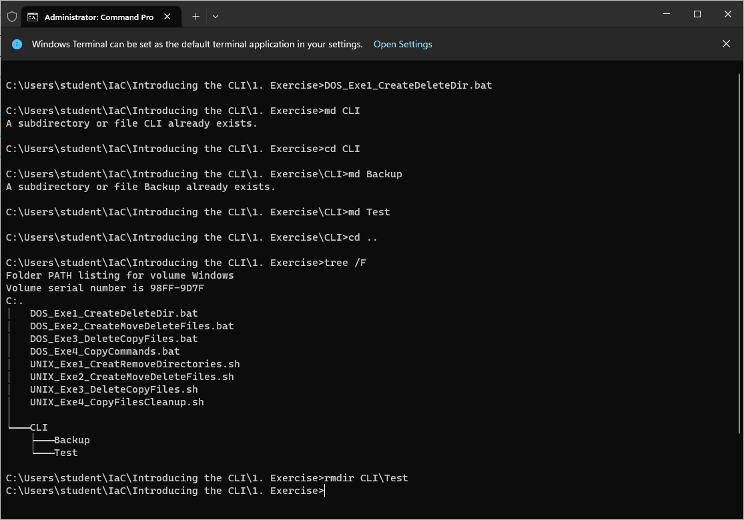

Figure 1: DOS: Create and Delete directories.

#### **Exercise 2:** Create, Move and Delete files.

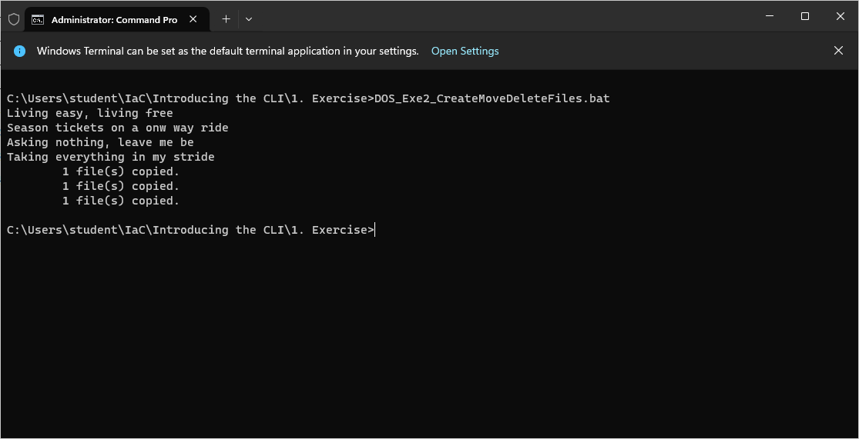

Figure 2: DOS: Create, Move and Delete files.

#### Exercise 3: Delete and Move files.

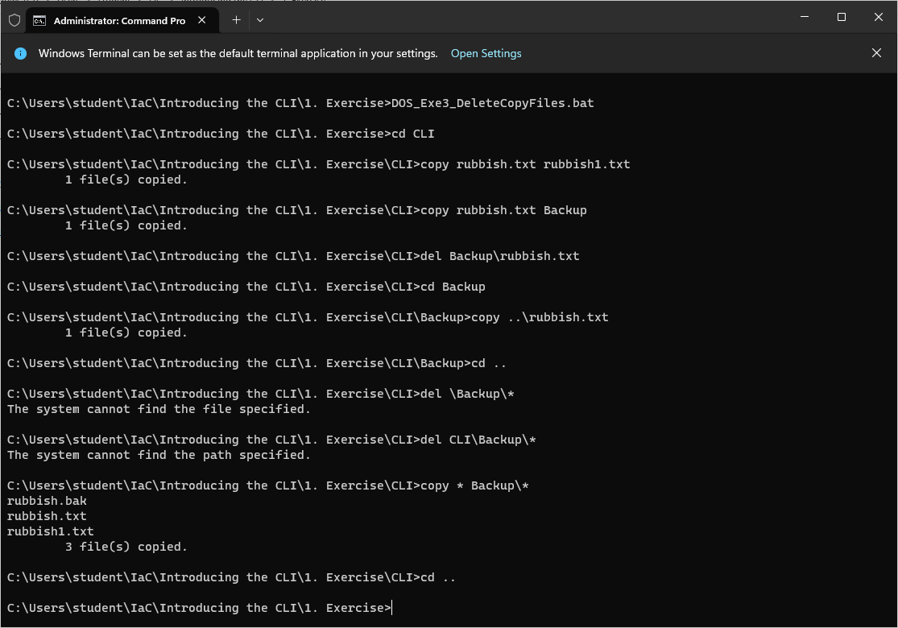

Figure 3: DOS: Delete and Move files.

#### Exercise 4: Copy command types.

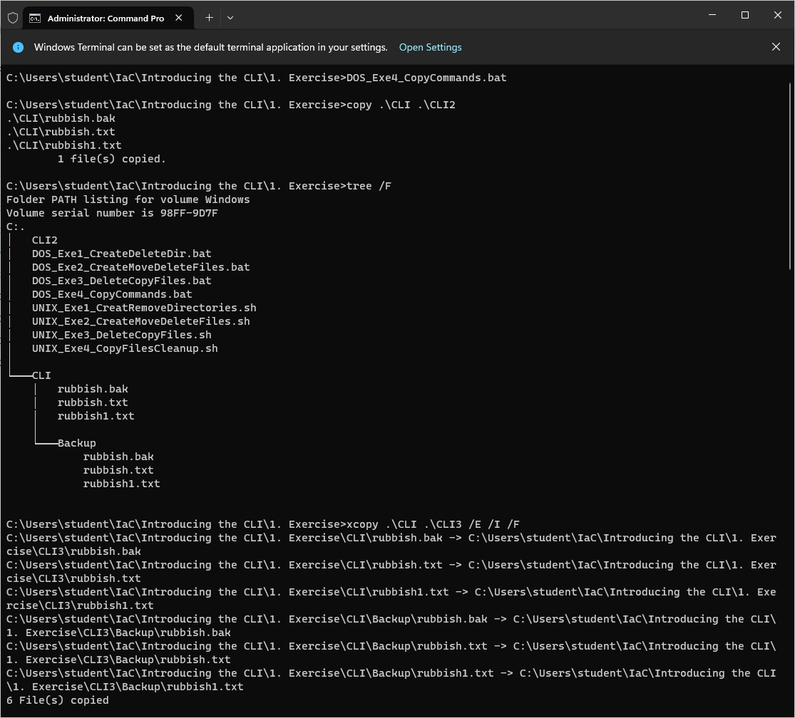

Figure 4: DOS: Copy command types

### UNIX Shell Results:

#### Exercise 1: Create and Delete directories.

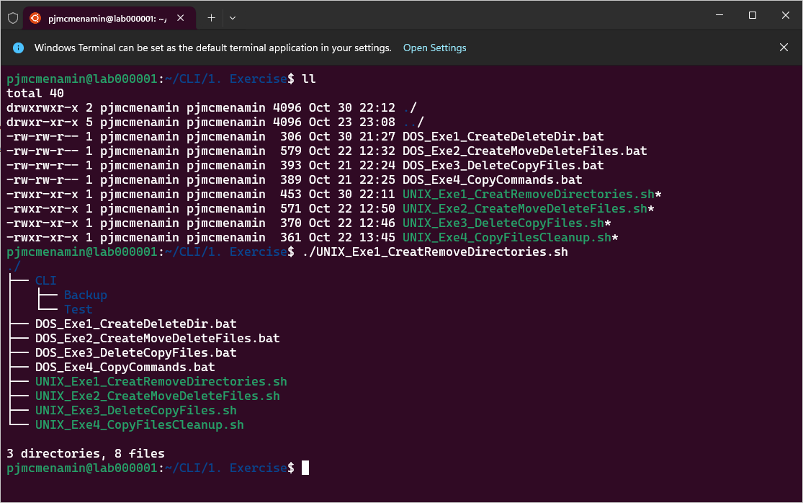

Figure : Create and Delete directories.

#### **Exercise 2:** Create, Move and Delete files.

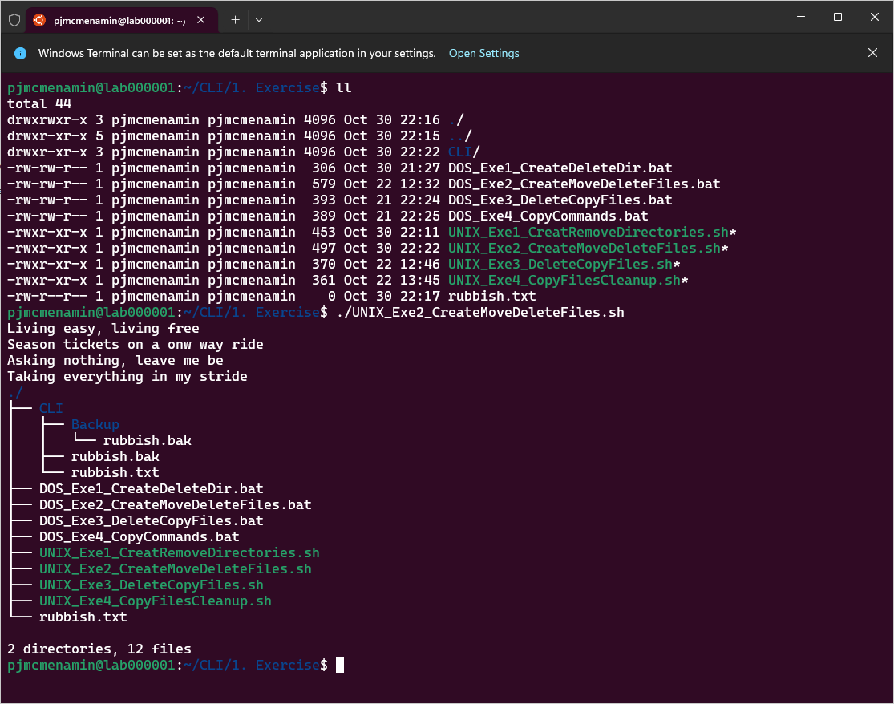

Figure : Create, Move and Delete files.

#### **Exercise 3:** Delete and Move files.

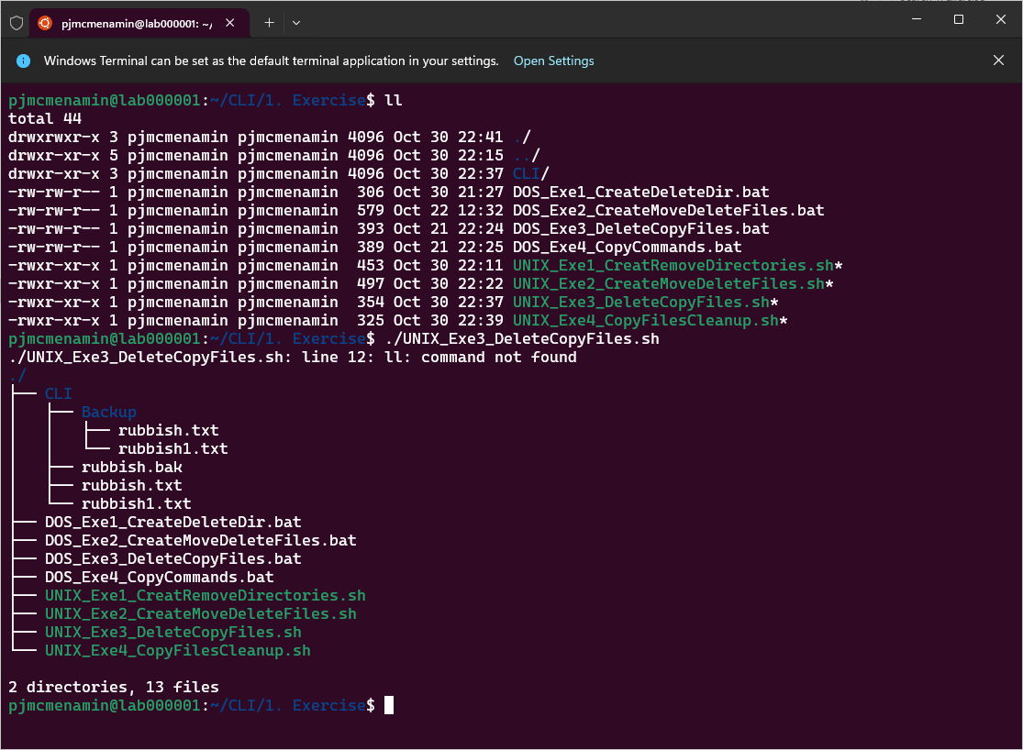

Figure : Delete and Move files.

#### **Exercise 4:** Copy files and Remove redundant directories.

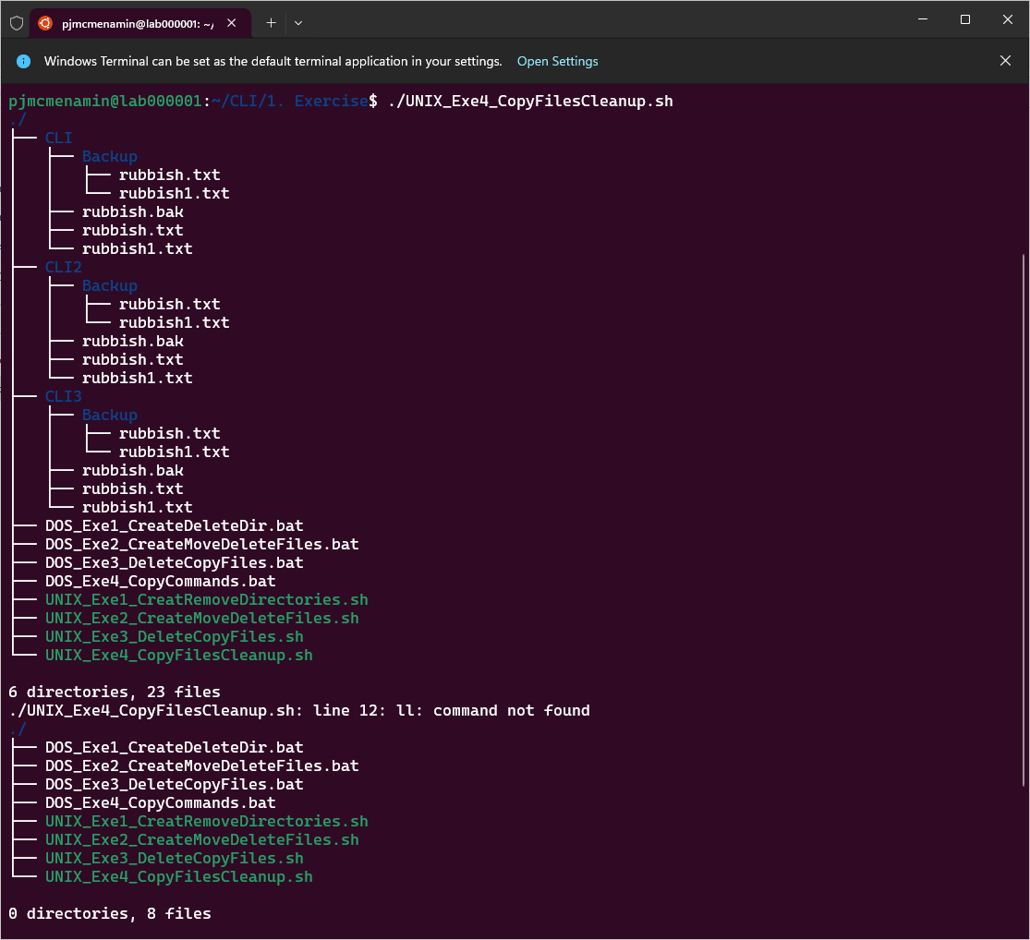

Figure : Copy files and Remove redundant directories.